**Final Project Report**

1. **Theme**

Vote System

1. **Sub-theme / Topic**

1. Anime character crimes summary

2. Vote for anime characters that deserve to be kill

1. **User Story**
2. prospective voters open the website and the first thing that appears is the landing page.
3. on the landing page there is a button that will direct you to the login page.
4. After pressing the button, prospective voters can log into the electoral system by entering their email and password.
5. After logging in, prospective voters can see their character and criminal record
6. Before voting, prospective voters are encouraged to see evidence of crime by pressing 'Here' above the voting card.
7. After that, prospective voters can play video evidence of each character's crime
8. And then the prospective voter can return to the voting page by pressing 'kill?'
9. Potential voters can choose a character by pressing the vote button.
10. The last page will appear after that.
11. **Feature and Task**
12. Form Login - used to login users

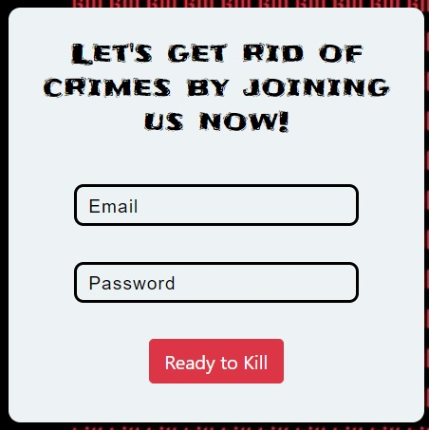

1. Vote Button - to select candidates for user voters

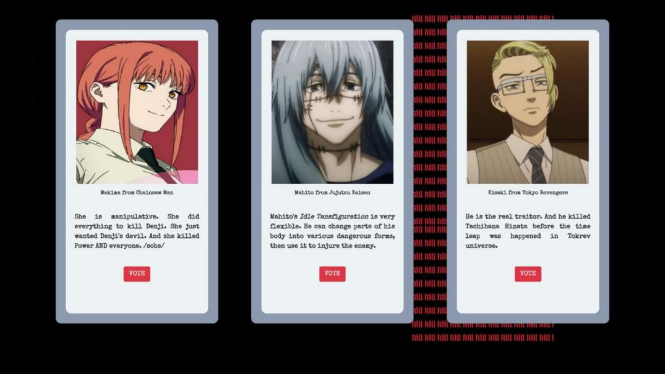

1. Video - to show videos

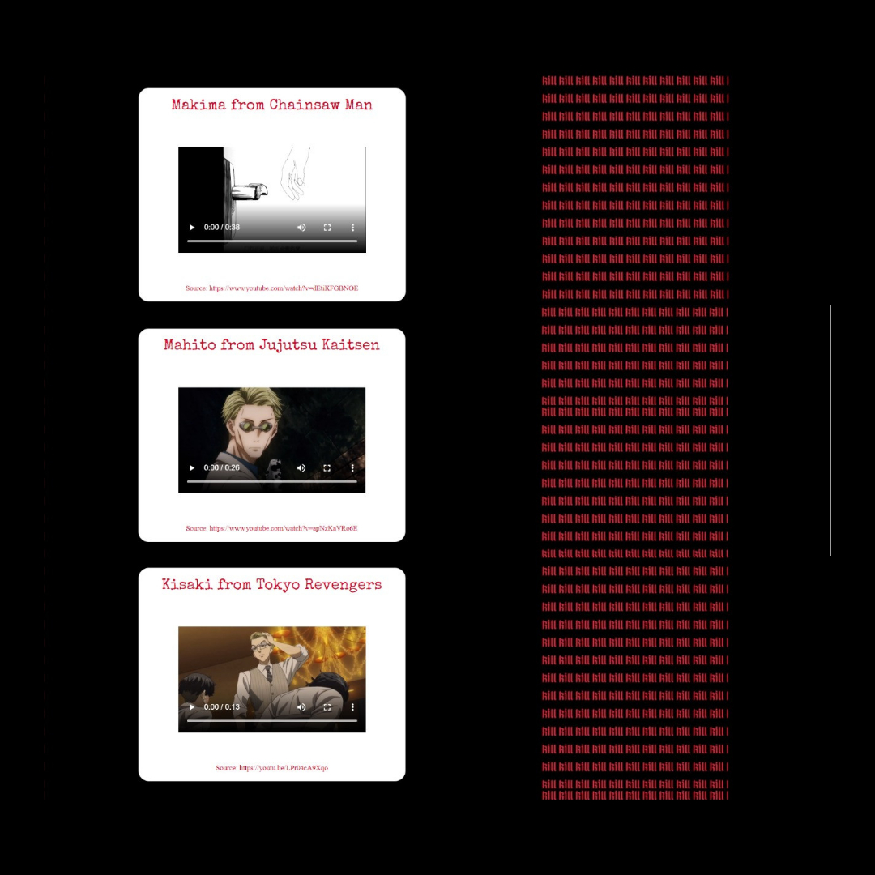

4.Last Page



1. **User Interface**
2. Landing Page / Home Page

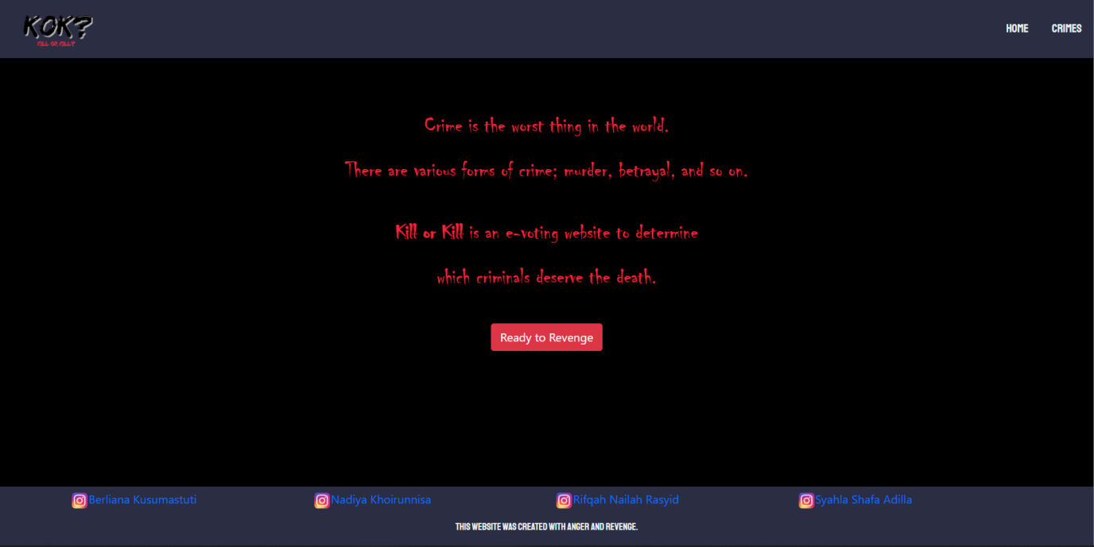

1. Login Page

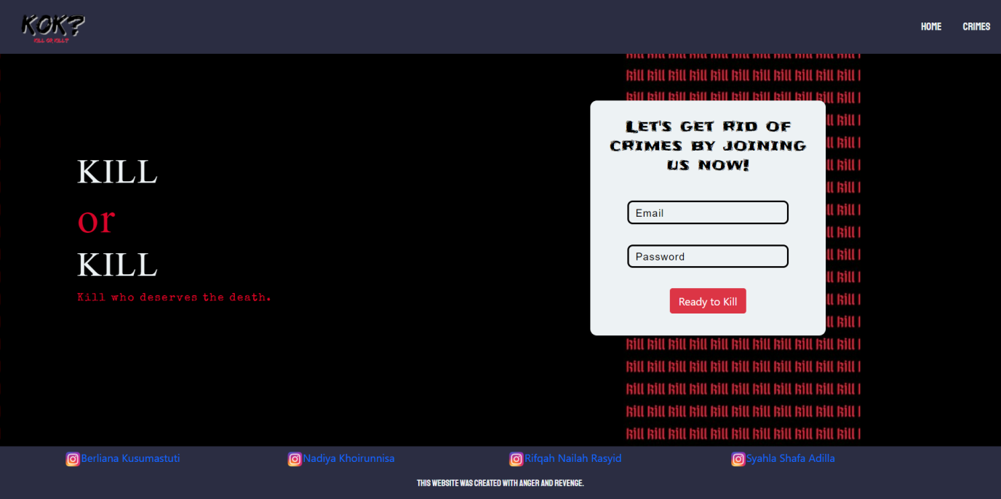

1. Vote Page

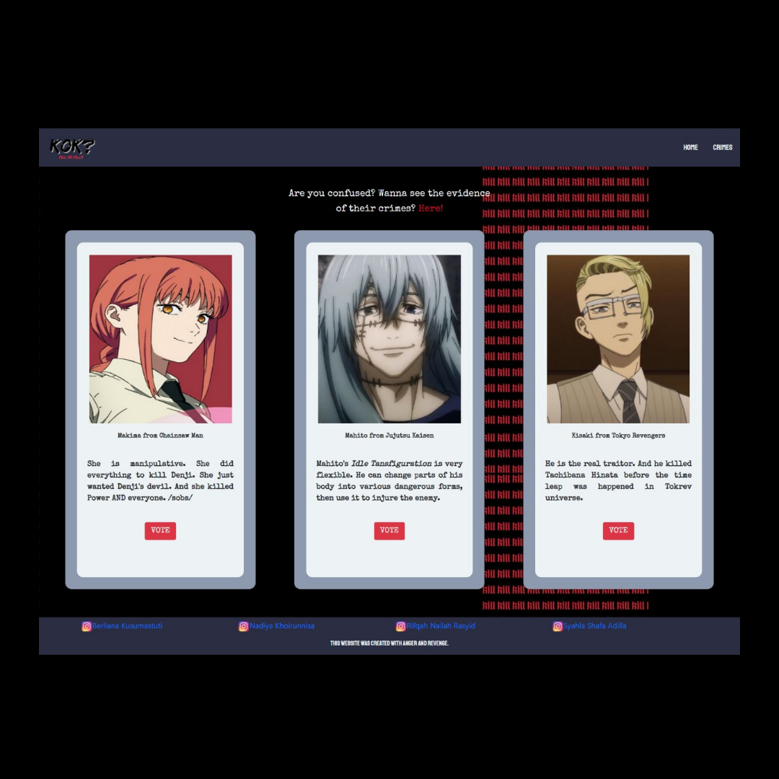

1. Video Page / Crimes Page

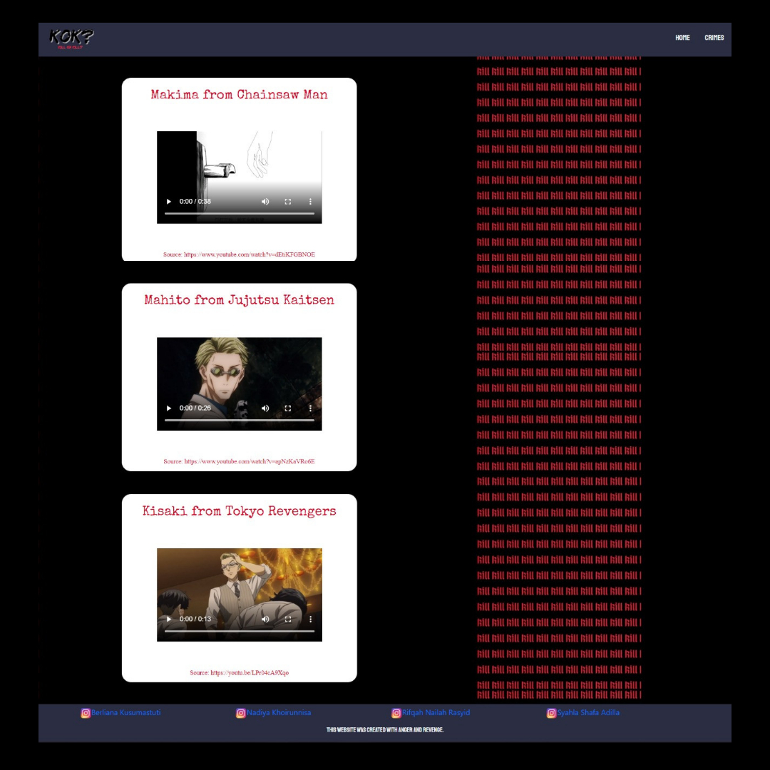

1. Last Page

